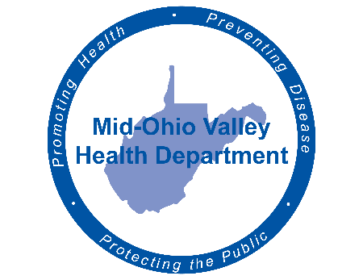
Mid-Ohio Valley Health Department
211 Sixth Street
Parkersburg, WV 26101
Media Advisory
Contact Information:
Mid-Ohio Valley Health Department
Carrie Brainard
304-420-1479
Cell: 304-488-3305
Carrie.L.Brainard@wv.gov

For Immediate Release
COVID-19 Care at Home

Parkersburg, WV April 17, 2020 – The Mid-Ohio Valley Health Department (MOVHD) now reports a total of 29 cases in Wood county which is an increase of two today. Wirt and Roane counties remain at two cases each. Pleasants is still at one, and Calhoun and Ritchie counties still do not have reported confirmed cases.
Governor Justice's order to test all residents and staff in Nursing Home for COVID-19 is to be done by the West Virginia Division of Health and Human Resources (WVDHHR) with assistance of the West Virginia National Guard (WVNG) and help from the MOVHD. We have not been informed at this time when and how the testing will be done and any help that we may be asked to provide. To the best of our ability we will expeditiously respond to any request from the WVDHHR or WVNG. We will update this information as we get further details.
Fortunately, most people who get sick with COVID-19 will have only a mild illness and should recover at home. Care at home can help stop the spread of COVID-19 and help protect people who are at risk for getting seriously ill from COVID-19.
If you are caring for someone at home, prevent the spread of germs, treat symptoms, and monitor for emergency signs.
If you develop emergency warning signs for COVID-19 get medical attention immediately. Emergency warning signs include:
- Trouble breathing
- Persistent pain or pressure in the chest
- New confusion or inability to arouse
- Bluish lips or face
This list is not all inclusive and consult your medical provider for any other symptoms that are severe or concerning. Call 911 if you have a medical emergency: Notify the operator that you have, or think you might have, COVID-19. If possible, put on a cloth face covering before medical help arrives.
Updated information is available at www.movhd.com; information about guidance and protocols are available at www.cdc.gov (COVID banner) or www.wv.gov (COVID-19 tab). Operators are available 24/7 at the toll-free West Virginia Coronavirus hotline at 1-800-887-4304 to provide accurate information about COVID-19, the risk to the public, and the state’s response.

###

