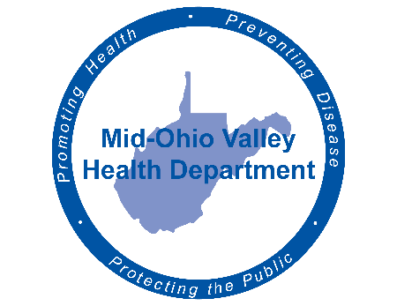
Mid-Ohio Valley Health Department
211 Sixth Street
Parkersburg, WV 26101
Media Advisory
Contact Information:
Mid-Ohio Valley Health Department
Carrie Brainard
304-420-1479
Cell: 304-488-3305
Carrie.L.Brainard@wv.gov
For Immediate Release
First Case of COVID-19 Confirmed in Pleasants County

Parkersburg, WV March 27, 2020 – The Mid-Ohio Valley Health Department (MOVHD) confirms that we have been notified of a Pleasants County resident has tested positive for COVID-19.
After being informed of a positive COVID-19 test result, the MOVHD personnel begin an investigation. If you are a person who was identified as a contact, MOVHD will reach out to you to assess, give guidance and monitor for signs and symptoms of illness.

To be infected with COVID-19, you generally need to be in close contact with a sick person.
Close contact includes living in the household with a person with COVID-19, caring for that patient, being within six feet of that person or being in direct contact with their secretions.

If you have been in contact with someone with a confirmed case of COVID-19, remain at home and monitor your temperature twice a day and report any coughing, wheezing, sneezing or shortness of breath to your health care provider and inform them that you have been exposed to COVID-19. Testing must be determined by your health care provider.

It is important that citizens take Governor Justice’s Stay at Home Order seriously. If you must go out, use every precaution – physical distancing of at least six feet away when standing in line for groceries and take out, washing hands with warm soapy water for at least 20 seconds, and being aware of surfaces that may have germs.

When people ignore the Stay at Home Order, you may jeopardize not only yourself but all of those that you come in contact.

If you want information about what to do if exposed to COVID-19 and other items, you can access links at www.movhd.com; information about guidance and protocols are available at www.cdc.gov (COVID banner) or www.wv.gov (COVID-19 tab). Operators are available 24/7 at the toll-free West Virginia Coronavirus hotline at 1-800-887-4304 to provide accurate information about COVID-19, the risk to the public, and the state’s response.

