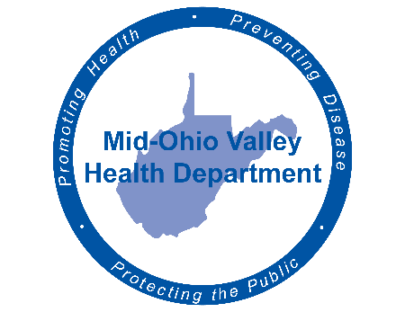
Mid-Ohio Valley Health Department
211 Sixth Street
Parkersburg, WV 26101
Media Advisory
Contact Information:
Mid-Ohio Valley Health Department
Carrie Brainard
304-420-1479
Cell: 304-488-3305
Carrie.L.Brainard@wv.gov
For Immediate Release
First Case of COVID-19 Confirmed in Wirt County

Parkersburg, WV March 28, 2020 – A Wirt County resident has tested positive for COVID-19. This information was confirmed by the Mid-Ohio Valley Health Department (MOVHD) today. The MOVHD response team will be contacting all individuals identified as being connected to the case.
As a reminder, everyone that has been tested for COVID-19 should self-quarantine until results are received to avoid taking chances of spreading the virus.
If you have been in contact with someone with a confirmed case of COVID-19, remain at home and monitor your temperature twice a day and report any coughing, wheezing, sneezing or shortness of breath to your health care provider and inform them that you have been exposed to COVID-19. Testing must be determined by your health care provider.

Everyone should stay at home unless absolutely necessary. If you must go out, use every precaution – physical distancing of at least six feet away when standing in line for groceries and take out, washing hands with warm soapy water for at least 20 seconds, and being aware of surfaces that may have germs.

If you want information about what to do if exposed to COVID-19 and other items, you can access links at www.movhd.com, www.cdc.gov (COVID banner) or www.wv.gov (COVID-19 tab). Operators are available 24/7 at the toll-free West Virginia Coronavirus hotline at 1-800-887-4304 to provide accurate information about COVID-19, the risk to the public, and the state’s response.

