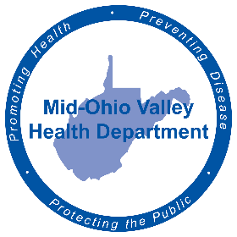
FOR IMMEDIATE RELEASE
June 21, 2022
Amy Phelps, Public Information Officer
Amy.j.phelps@wv.gov
Cell phone: 304-588-9697
Direct line: 304-420-1468

Back to School Vaccines
The Mid-Ohio Valley Health Department announces they are open for appointments for children’s back-to-school vaccines.
Appointments are being scheduled now through the end of August to get children ready to go back to school, said Rebecca Eaton, clinical director of the Mid-Ohio Valley Health Department.
Vaccines available include TDAP and meningitis, as well as boosters for both, Gardasil for ages 9-45 and meningitis B for those 16 and older.
The MOV Health Department takes most private insurance as well as Medicaid, but those without insurance are welcome to make an appointment as well. An administrative fee will be charged, however - $19.85 for one vaccine or $36 for more than one. No one will be turned away if they cannot pay the fee, Eaton said.
A parent’s signature is required for vaccines, as well as the child’s previous shot record. Please bring a copy of your insurance card to the appointment.
To make an appointment in Wood County, call 304-485-7374 ext. 123 or 124.
The Ritchie and Pleasants County branches will be holding Back-to-School Vaccine Clinics. They will also be by appointment only. Ritchie County’s clinic will be Wednesday, Aug. 17 at 125 W Main St. in Harrisville. Appointments can be made by calling 304-643-4082. Pleasants County’s clinic will be Monday, Aug. 15 at 605 Cherry St. in St. Mary’s. Appointments can be made by calling 304-684-2461.
###
The Mid-Ohio Valley Health Department serves Wood, Wirt, Calhoun, Pleasants, Ritchie and Roane Counties. It is located at 211 Sixth St. in Parkersburg. The offices are open 8 a.m. to 4 p.m. Call 304-485-7374 or visit the website, movhd.com for more information. Follow them at Mid-Ohio Valley Health Department MOVHD on Facebook and @MOVHealthDept on Instagram and Twitter.

