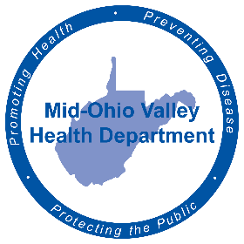
FOR IMMEDIATE RELEASE
June 1, 2022
Amy Phelps, Public Information Officer
Amy.j.phelps@wv.gov
Cell phone: 304-588-9697
Direct line: 304-420-1468

MOHD unveils Community Health Initiative

The local community’s overall health is important, and the Mid-Ohio Valley Health Department wants to do what they can to empower residents to take their health into their own hands.
The MOVHD has recently kicked off their latest Community Health Initiative, Step Up to a Healthy Life, using key areas or “steps,” for residents to focus on, with three to-do actions in each step that can be done for free, at any age.
“We wanted to create an initiative that would engage people in the community by empowering them, but also make it accessible to them,” said Malcolm Lanham, director of Community Health. “With COVID, we have learned that people need to start taking better care of their health. (The Initiative) makes it accessible by giving them first steps that would have immediate impacts or effects on their health and would financially be accessible.”
Through the steps of Nutrition, Sleep, Movement, Community and Lifestyle, MOVHD will be addressing metabolic syndrome, mental health and rebuilding people’s immune systems.
Through the kick-off of this initiative, the MOVHD has build a Facebook group, Step Up to a Healthy Life, to post content to help the community achieve these goals. In addition, another Facebook group, MOV Ruck Club, will bring a local club to the area to help with exercise goals. Rucking is a term for walking with weight, usually a heavy backpack.
For more information about the initiative, visit the MOVHD’s Facebook pages, facebook.com/MidOhioValleyHealthDepartment, facebook.com/groups/stepuptoahealthylife and facebook.com/groups/709645003792451/.
###
The Mid-Ohio Valley Health Department serves Wood, Wirt, Calhoun, Pleasants, Ritchie and Roane Counties. It is located at 211 Sixth St. in Parkersburg. The offices are open 8 a.m. to 4 p.m. Call 304-485-7374 or visit the website, movhd.com for more information. Follow them at Mid-Ohio Valley Health Department MOVHD on Facebook and @MOVHealthDept on Instagram and Twitter.

