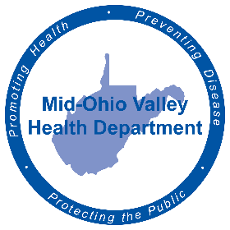
FOR IMMEDIATE RELEASE
June 21, 2022
Amy Phelps, Public Information Officer
Amy.j.phelps@wv.gov
Cell phone: 304-588-9697
Direct line: 304-420-1468

Family Planning Clinic Available
The Mid-Ohio Valley Health Department announces its upcoming Family Planning Clinic for Pleasants County.
Family planning services include pregnancy testing; information for those trying to achieve pregnancy; medical history; physical, gynecological, breast and testicular exams; laboratory services; diagnosis and limited treatment of sexually transmitted diseases; contraceptive supplies; education and counseling and referrals for medical issues and sterilization procedures.
Eligibility requirements are as follows:
- Female/male of childbearing age
- Women seeking pregnancy
- Income is at or below 250% of the current Federal Poverty Level and uninsured or under insured
- Fees assessed on gross monthly income and family size according to the Federal Poverty Guidelines
- Other programs available if annual income is over the income guidelines.
The clinics are held once a month in their perspective counties at their local MOV Health Department and require appointments. The Pleasants County Family Planning Clinic will be on Friday, July 8, at 605 Cherry St. in St. Mary’s. Appointments can be made by calling 304-684-2461.
###
The Mid-Ohio Valley Health Department serves Wood, Wirt, Calhoun, Pleasants, Ritchie and Roane Counties. It is located at 211 Sixth St. in Parkersburg. The offices are open 8 a.m. to 4 p.m. Call 304-485-7374 or visit the website, movhd.com for more information. Follow them at Mid-Ohio Valley Health Department MOVHD on Facebook and @MOVHealthDept on Instagram and Twitter.

