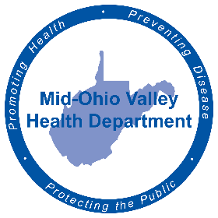
FOR IMMEDIATE RELEASE
July 25, 2022
Amy Phelps, Public Information Officer
Amy.j.phelps@wv.gov
Cell phone: 304-588-9697
Direct line: 304-420-1468

Contraceptives available at MOVHD
PARKERSBURG - Women’s reproductive health is at the forefront of national discussion currently. The Mid-Ohio Valley Health Department wants everyone to know the current options available to our residents.
“We are in good shape,” said Rebecca Eaton, clinical director of MOVHD, about the amount of options of available locally.
The Mid-Ohio Valley Health Department offers birth control pills, Nuvaring, patches, IUDs, Nexplanon – an implant in the arm - and condoms, as well as the birth control commonly known as the Morning After pill. Staff can also give education on the Basal Body Temperature method, as well as male and female sterilization. “We can help with the paperwork to get the surgery sooner,” said Eaton.
These Family Planning services are billed through the patient’s insurance, Medicaid and a sliding scale basis for those without insurance. There are confidential services that will also not send a physical bill to the patient.
For an appointment for family planning, contact 304-485-7374.

###
The Mid-Ohio Valley Health Department serves Wood, Wirt, Calhoun, Pleasants, Ritchie and Roane Counties. It is located at 211 Sixth St. in Parkersburg. The offices are open 8 a.m. to 4 p.m. Call 304-485-7374 or visit the website, movhd.com for more information. Follow them at Mid-Ohio Valley Health Department MOVHD on Facebook and @MOVHealthDept on Instagram and Twitter.

