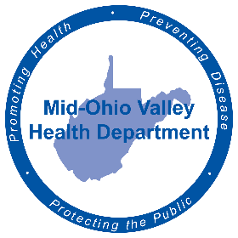
FOR IMMEDIATE RELEASE
Aug. 22, 2022
Amy Phelps, Public Information Officer
Amy.j.phelps@wv.gov
Cell phone: 304-588-9697
Direct line: 304-420-1468

Step Up to a Healthy Life class announced
PARKERSBURG – The Mid-Ohio Valley Health Department announces its first classes for its new health initiative, Step Up to a Healthy Life.
The first class will be held from 9 a.m. to noon Saturday, Aug. 27 at 211 Sixth St. in Parkersburg, in the first-floor conference room. A second class is scheduled for 9 a.m. to noon 4911Sept. 24. Seats are limited and registration is required. To register, visit https://tinyurl.com/2p9279u3 and select the date and number of seats needed.
The class will discuss all the steps in the program, as well as giving information on how to live a healthy lifestyle.
A Facebook page for the initiative can be found linked to the Mid-Ohio Valley Health Department Facebook page. It will have up-to-date information and health recommendations for the program.
###
The Mid-Ohio Valley Health Department serves Wood, Wirt, Calhoun, Pleasants, Ritchie and Roane Counties. It is located at 211 Sixth St. in Parkersburg. The offices are open 8 a.m. to 4 p.m. Call 304-485-7374 or visit the website, movhd.com for more information. Follow them at Mid-Ohio Valley Health Department MOVHD on Facebook and @MOVHealthDept on Instagram and Twitter.

